## Chapter 1

## 1.0 INTRODUCTION

Gas leakage is a serious problem and nowadays it is observed in many places like residences, industries, and vehicles like Compressed Natural Gas (CNG), buses, cars, etc. It is noticed that due to gas leakage, dangerous accidents occur. The Liquefied petroleum gas (LPG), or propane, is a flammable mixture of hydrocarbon gases used as fuel in many applications like homes, hostels, industries, automobiles, and vehicles because of its desirable properties which include high calorific value, less smoke, less soot, and meager harm to the environment. Liquid petroleum gas (LPG) is highly inflammable and can burn even at some distance from the source of leakage. This energy source is primarily composed of propane and butane which are highly flammable chemical compounds. These gases can catch fire easily.

In homes, LPG is used mainly for cooking purposes. When a leak occurs, the leaked gases may lead to an explosion. Gas leakage leads to various accidents resulting in both material loss and human injuries. Home fires have been occurring frequently and the threat to human lives and properties has been growing in recent years. The risks of explosion, fire, suffocation are based on their physical properties such toxicity, flammability, etc. The number of deaths due to the explosion of gas cylinders has been increasing in recent years. The Bhopal gas tragedy is an example of accidents due to gas leakage.

The reason for such explosions is due to substandard cylinders, old valves, no regular checking of gas cylinders, worn out regulators and a lack of awareness of handling gas cylinders. Therefore, the gas leakage should be detected and controlled to protect people from danger. An odorant such as Ethyl Mercaptan is added to LPG, so that leaks can be detected easily by most people. However, some people who have a reduced sense of smell may not be able to rely upon this inherent safety mechanism. A gas leakage detector becomes vital and helps to protect people from the dangers of gas leakage.

Smoke detector has been reviewed as a fundamental component of active fire detection strategy of modern commercial and residential building.

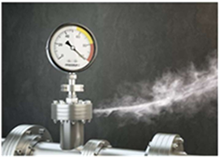

**Chapter 2**

## 2.0 OBJECTIVE

* The primary objective of the Gas leakage detection system is to detect the malfunctioning of the pressurized gas system in order to prevent the accumulation of the gases so that the explosion does not happen.
* The system can also be used for other applications in the industries or companies that depend on LPG and natural gas in their operations.
* The device is intended for use in household safety where appliances and heaters that use natural gas or LPG may be a source of risk.
* This system intends to prevent accidents related to the gas leakage and smoke detector.

## Chapter 3

## 3.0 BASIC COMPONENTS

 

Figure 2: Arduino UNO Mini

 

 

**Chapter 4**

**4.0 METHODOLOGY**

Figure 3 : Principle of Methodology

* Semiconductor sensors are used to detect LPG gas and smoke, Here MQ-2 semiconductor sensor is used.
* Sensitive material of the MQ-2 gas sensor is SnO2, which has lower conductivity in clean air.
* When the target combustible gas or smoke exists, the sensor conductivity increases along with the rising gas or smoke concentration.
* The MQ-2 gas sensor has a high sensitivity to Propane, Hydrogen, Methane, LPG, and response to Natural gas and Smoke too.
* The sensor could be used to detect different combustible gases, especially Methane.
* It has a low cost and is suitable for different applications.
* The MQ-2 can detect gas concentrations anywhere from 200 to 10,000 ppm.
* Overall, our methodology involved a combination of hardware assembly, circuit design and programming, and system testing to create an effective gas leakage and smoke detector system with a buzzer to prevent accidents caused by gas leakage.

**Chapter** **5**

### 5.0 WORKING MODEL

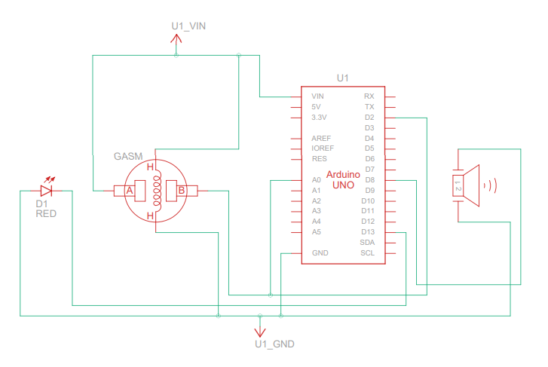

Figure 4 : Circuit diagram on gas leakage and smoke detection system

* This system is based on the Arduino UNO and MQ-2 gas sensor. When the sensor detects gas like Propane, Hydrogen, Methane, LPG, Natural gas and smoke in the atmosphere, it will give digital output as 1 or else it give digital output as 0.
* Arduino will convert the sensor output into digital input. If the sensor output is high, then the buzzer will alarm, LED glows and “Gas detected” \ “Smoke Detected” will be displayed in the serial Monitor. If the sensor output is low then there will be no indication in the buzzer, LED and in the serial monitor.
* For the design of a sensor-based gas leakage and smoke detector system the following hardware components are required. Arduino UNO, MQ-2 Sensor, Mini Breadboard, Buzzer, Led, Jumper Wires. The gas leakage and smoke detector system model cost INR 800. The device is portable, light weight, user friendly and efficient with multi-functional features.

**Chapter 6**

**6.0 COST ESTIMATION**

|  |  |  |  |
| --- | --- | --- | --- |
| **Components** | | **Quantity** | **Prize in INR** |
| Arduino UNO | | 1 | 450/- |
| MQ-2 Sensor | | 1 | 160/- |
| Mini Breadboard | | 1 | 70/- |
| Buzzer | | 1 | 20/- |
| Led | | 10 | 10/- |
| Jumper Wires | | 20 | 40/- |
| Arduino USB Cable | | 1 | | 50/- |
| **TOTAL** | | | | **800/-** |

**Chapter 7**

**7.0 SCOPE FOR FUTURE WORK**

* Overall, software and hardware parts of the systems have been developed and tested by introducing a small amount of LPG near gas sensor module.
* One of the notable future functions of this system is to add a sub system where wastage of gas and the uses of gas can be monitored using this system.
* The system is flexible as a greater number of sensors and relays can be added to it according to the whole LPG supply setup in those premises.
* This is an automatic gas detection, control and alert system. In future this system will have a feature where it can notify the emergency services if any accidents happen.
* This system can also be used to detect and deter smokers in areas where smoking is prohibited.
* A mobile app and web- based app for real time monitoring also will be added. In the user app for this system many smart features will be added.
* The overall features will make the system safer for the users. The system will be optimized for use in many places like the car, the home, industries and many other places. After designing the final prototype with smart multifunctional features, the system will be implemented in real life scenarios as a pilot project.

**Chapter 8**

**8.0 CONCLUSION**

### This is a low-cost, low power, lightweight, portable, safe, user friendly, efficient, multi featured and simple system device for detecting gas and smoke. Gas leakage and smoke detections will not only provide us with significance in the health department but it will also lead to raise our economy, because when gas leaks it not only contaminates the atmosphere but also wastage of gases will hurt our economy. The proposed system will cost only INR 1000 which is easily affordable even for poor people. In the open literatures it is noticed that much work has not been done for a smart gas detection system. In future, more advanced features will be integrated with this system which will provide users with more safety and relaxation. The proliferation of handheld devices has led to developments in the field of smart gas sensors, which has considerably widened their scope of application. The need for ensuring safety in workplaces is expected to be the key driving force for the market over the coming years.

### REFERENCES

1. Mahalingam, A.; Naayagi, R.T.; Mastorakis, N.E. Design and implementation of an economic gas leakage detector. In Proceedings of 6th International Conference on Circuits, Systems and Signals, Athens, Greece, 7–9 March 2012; pp. 20–24.
2. Attia, H.A.; Halah, Y.A. Electronic Design of Liquefied Petroleum Gas Leakage Monitoring, Alarm, and Protection System Based on Discrete Components. Int. J. Appl. Eng. Res. 2016, 11, 9721–9726.
3. Apeh, S.T.; Erameh, K.B.; Iruansi, U. Design and Development of Kitchen Gas Leakage Detection and Automatic Gas Shut off System. J. Emerg. Trends Eng. Appl. Sci. 2014, 5, 222–228. Eng. Proc. 2020, 2, 28 6 of 6
4. Soundarya, T.; Anchitaalagammai, J.V.; Priya, G.D.; Karthickkumar, S.S. C-Leakage: Cylinder LPG Gas Leakage Detection for Home Safety. IOSR J. Electron. Commun. Eng. 2014, 9, 53–58.
5. Shrivastava, A.; Prabhaker, R.; Kumar, R.; Verma, R. GSM based gas leakage detection system. Int. J. Emerg. Trends Electr. Electron. 2013, 3, 42–45.

**APPENDIX**

**The program for Gas leakage and Smoke detection is given below**

int smokePin = 2; // DO pin of the MQ-2 sensor

int gasPin = A0; // Define the gas sensor analog input pin

int threshold = 500; // Define the gas threshold level

int smokeLevel = 0; // Variable to hold the smoke level

int buzzerPin = 8; // Buzzer pin

int ledPin = 13; // LED pin

void setup() {

  pinMode(smokePin, INPUT); // Set the smoke pin as input

  pinMode(gasPin, INPUT); // Set gas sensor pin as input

  pinMode(buzzerPin, OUTPUT); // Set the buzzer pin as output

  pinMode(ledPin, OUTPUT); // Set the LED pin as output

  Serial.begin(9600); // Start serial communication

}

void loop() {

  int gasValue = analogRead(gasPin); // Read gas sensor value

  smokeLevel = analogRead(gasPin); // Read the smoke level from the sensor

  Serial.print("Smoke Level: "); // Print the smoke level to the serial monitor

  Serial.println(smokeLevel);

  Serial.print("Gas Value: ");

  Serial.println(gasValue); // Print gas sensor value to serial monitor

  if (digitalRead(smokePin) == HIGH || smokeLevel > 400) { // If the smoke pin is high or smoke level is greater than 300

   digitalWrite(buzzerPin, HIGH); // Turn on the buzzer

   digitalWrite(ledPin, HIGH); // Turn on the LED

   Serial.println("Smoke detected!"); // Print gas detected message to serial monitor

  }

  else if (gasValue > threshold) { // If gas value is greater than threshold level

    Serial.println("Gas detected!"); // Print gas detected message to serial monitor

    digitalWrite(buzzerPin, HIGH); // Turn on the buzzer

    digitalWrite(ledPin, HIGH); // Turn on the LED

  }

  else if (gasValue < threshold){ // If gas value is lesser than threshold level

    Serial.println("Gas not detected!"); // Print gas detected message to serial monitor

    digitalWrite(buzzerPin, LOW); // Turn off the buzzer

    digitalWrite(ledPin, LOW); // Turn off the LED

  }

  else {

    digitalWrite(buzzerPin, LOW); // Turn off the buzzer

    digitalWrite(ledPin, LOW); // Turn off the LED

    Serial.println("Smoke not detected!"); // Print smoke detected message to serial monitor

  }

  delay(1000); // Delay for 100 milliseconds

}

**Schematic Hardware Design for a model**

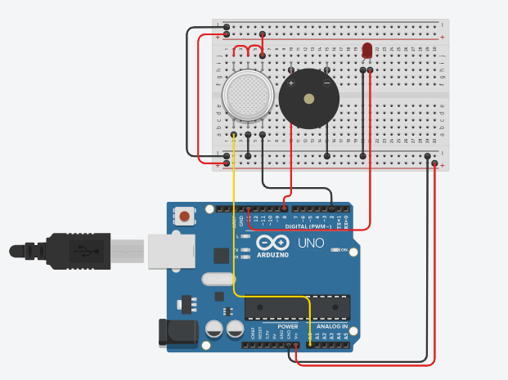

Figure 5 : Hardware Design